Name: __________________________________________ Date:_____________
Ms. Williams and Ms. Narracci Science 693
Word Splash: Air Masses
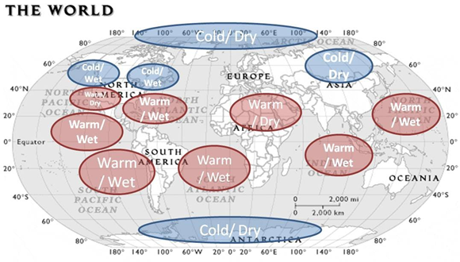
The weather on Earth is mainly determined by large sections of air called air masses. Air masses have the same moisture and temperature characteristics as the region that they formed over, or source region. The longer the air remains over its source region, it becomes larger and begins to match the characteristics associated with that region more. Air masses are named according to their source regions.
In general, air masses have a combination of four different traits depending on their source region. Air masses that form over land tend to be dry, while those that form over water tend to be moist. Meanwhile, those that form closer to the poles tend to be colder and those forming closer to the Equator tend to be warmer. For example, an air mass that forms over Mexico would be a warm/dry air mass.
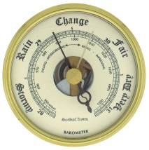
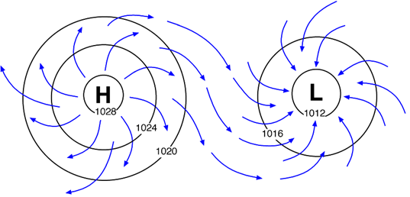
These air masses help to generate the different pressure systems over Earth. The two pressure systems are the high pressure systems and low pressure systems. In a high pressure system the wind blows in a clockwise motion away from the center of the pressure system. This creates an effect known as an anti-cyclone. This type of pressure system is associated with good weather. In low pressure systems, the wind blows inwards creating a counter-clockwise motion. This movement creates a cyclone, which is usually associated with stormy weather. Scientists use an instrument called a barometer to measure air pressure.

