Name: ___________________________________ Date: _____________
Ms. Williams and Ms. Narracci 691/693
“Tornado Alley”
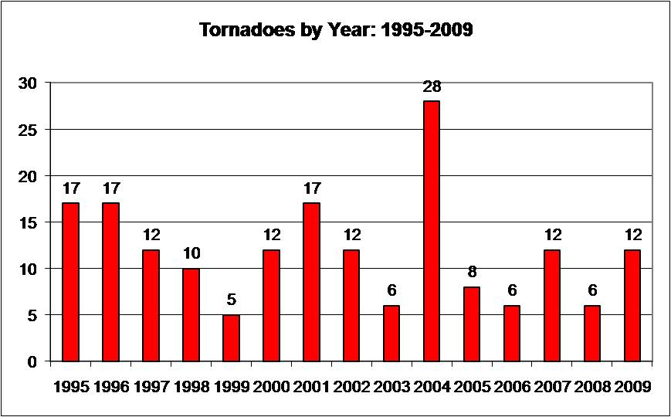
Directions: The chart below shows the number of tornadoes that occurred in Tornado Valley from 1995-2009. Use the chart to answer the following questions.

- Which year experienced the most tornadoes? The least?
________________________________________________________________________________________________________________________________________________
- What is the average number of tornadoes that Tornado Alley experienced from 1995-2009? (Remember to find an average add all the numbers and then divide by the total!)
________________________________________________________________________________________________________________________________________________
- Why do you think 2004 experienced such a large quantity of tornadoes?
________________________________________________________________________________________________________________________________________________________________________________________________________________________________________________________________________________________________________________________________________________________________________

