Research Organizer
Directions: Underneath this page, there are four sheets of paper attached. Each sheet has a new organizer on it. The organizer will have space for four facts and four different sources. Each organizer will be for a different paragraph in your paper. You can get the questions to focus each paragraph on from your research paper organizer. Remember paragraphs must have at least five sentences! An example of how you should organize your research organizers is below:
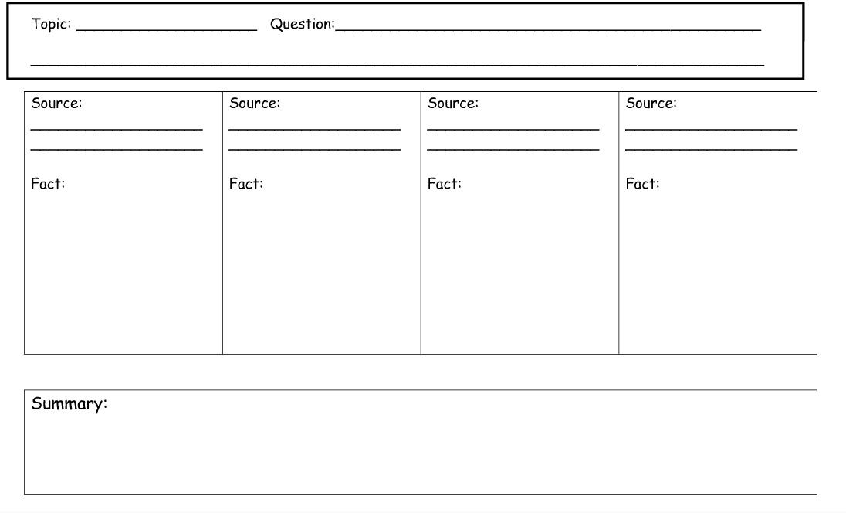
How do hurricanes get their names?
Hurricanes
Website:
Hurricanes get their names… (Formulate a few sentences as a rough draft for your paragraph!)
Fact 1
Research Organizer: Paragraph One
Research Organizer: Paragraph Two
Research Organizer: Paragraph Three

Research Organizer: Paragraph Four

