Group 1: Station Models
Please draw the 3 station models depicted below over their corresponding area on your weather maps:
66
Over Richmond, Virginia
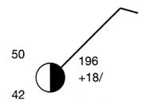
Over Detroit, Michigan

Over Seattle, Washington

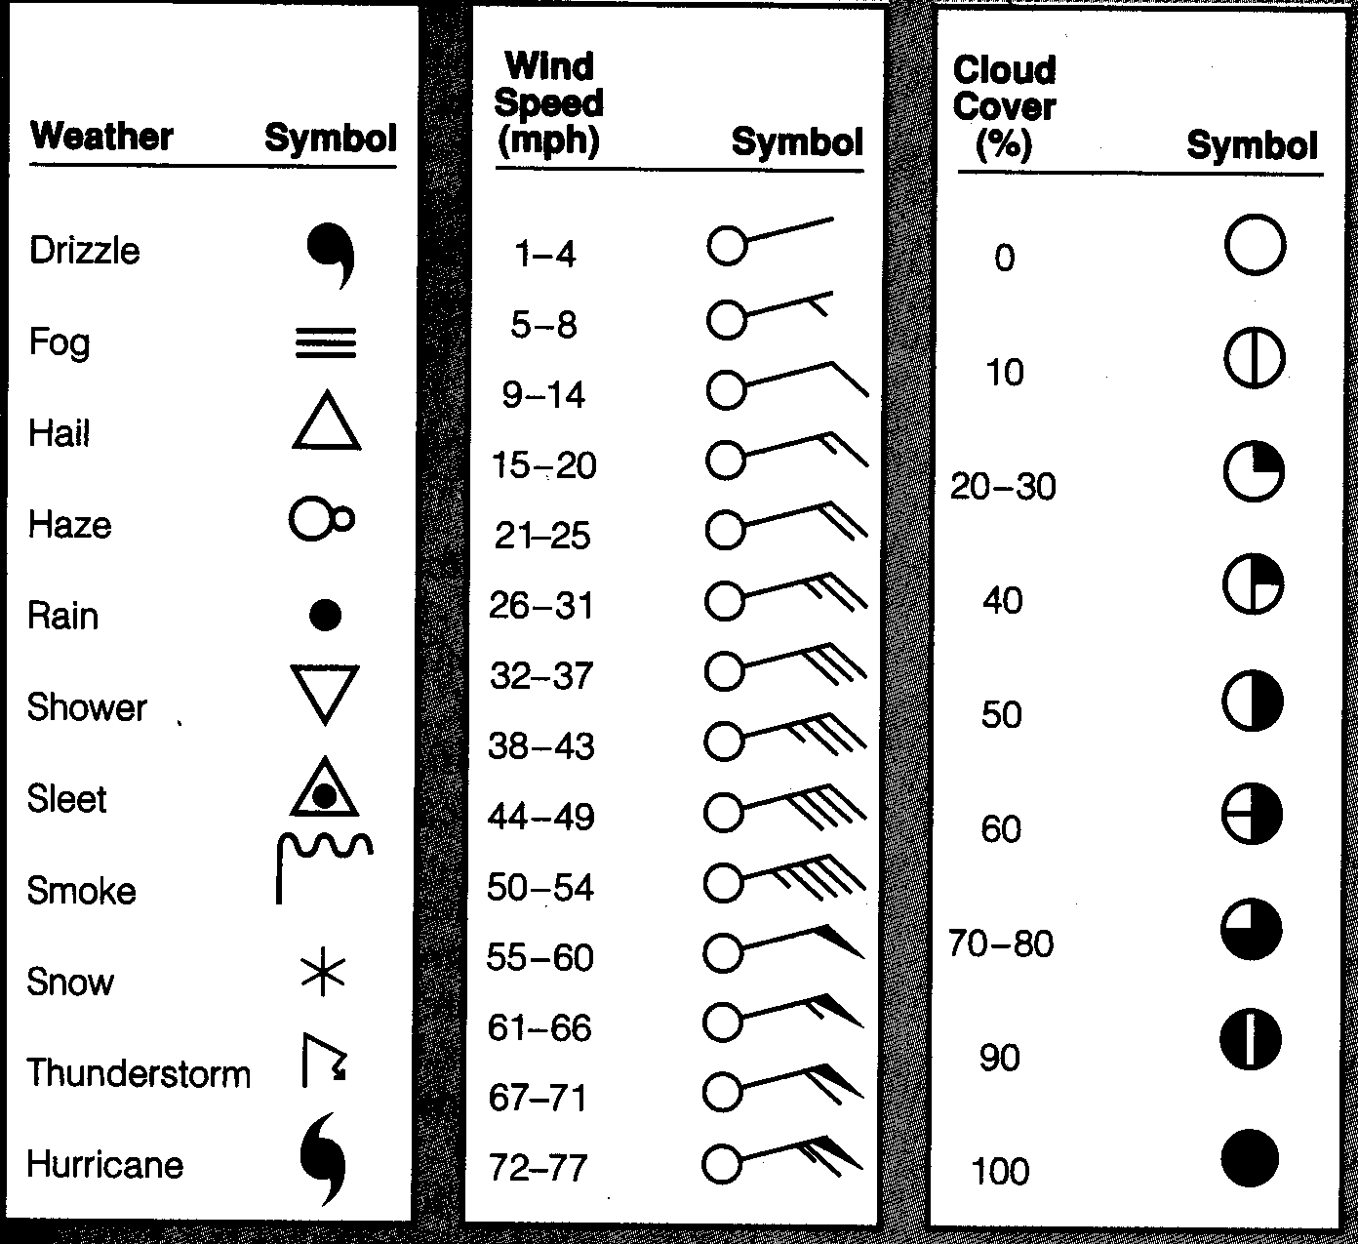
Key

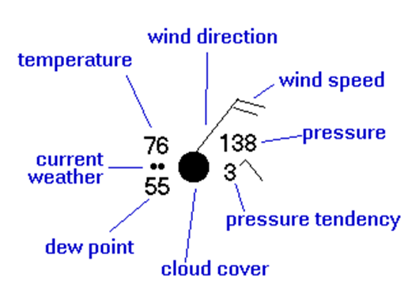
Remember…

Group 2: Weather Fronts
Please draw the four weather fronts below on your weather map.

A Warm Front Heading INTO Florida FROM the Gulf of Mexico
A Cold Front Heading INTO California FROM Oregon
A Stationary Front OVER Texas
An Occluded Front Heading INTO South Dakota FROM Nebraska
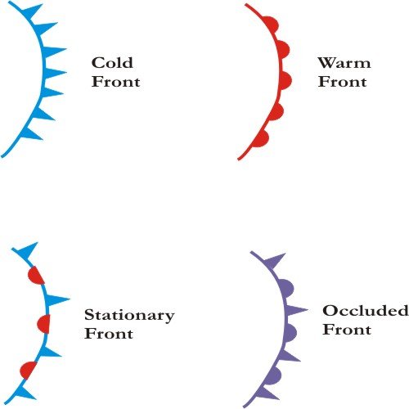

Group 3: Isotherms
Color in each section of equal temperature represented on your map with a specific color.
(Hint: The Warm the Temperature is the Closer the Red the Color it should be colored will be. Use the Rainbow’s Colors: Red, Orange, Yellow, Green, Blue, Indigo, and Violet)
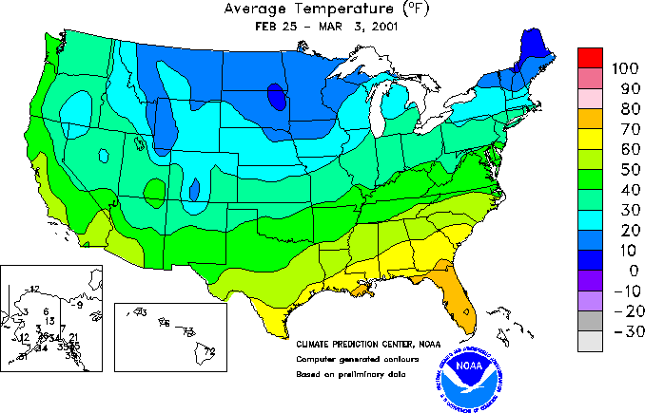
Example:

Group 4: Isobars and Pressure Systems
Connect the areas of Equal Pressure on your map and then label the High Pressure System with an H, and the Low Pressure System with a L.

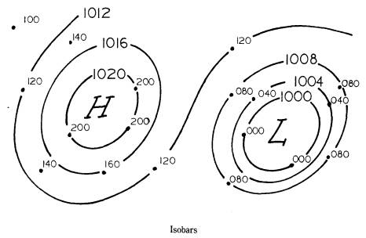
Example:

