Name: ___________________________________________ Date: _____________
Ms. Williams and Ms. Narracci 691/693
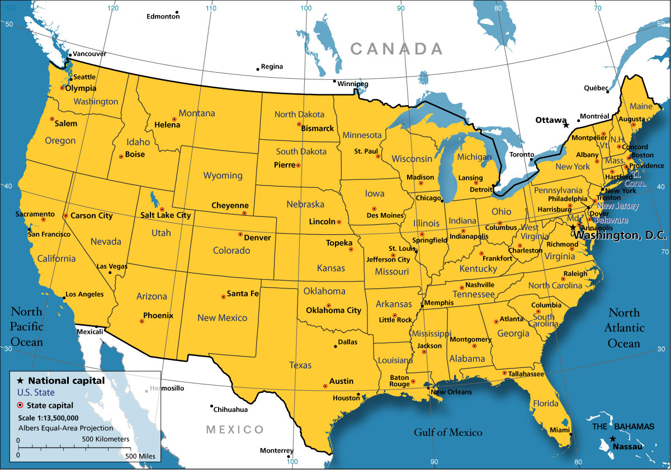
Fronts
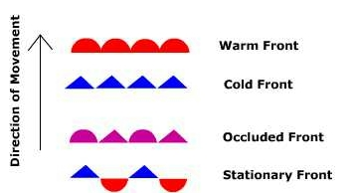
Key
- Draw a COLD FRONT heading into NEBRASKA from South Dakota.
- Draw a WARM FRONT heading into TEXAS from Mexico.
- Draw an OCCLUDED FRONT heading into CALIFORNIA from Oregon.
- Draw a STATIONARY FRONT over NEW YORK.

