Name: ____________________________________ Date: _____________
Ms. Williams and Ms. Narracci 693/691
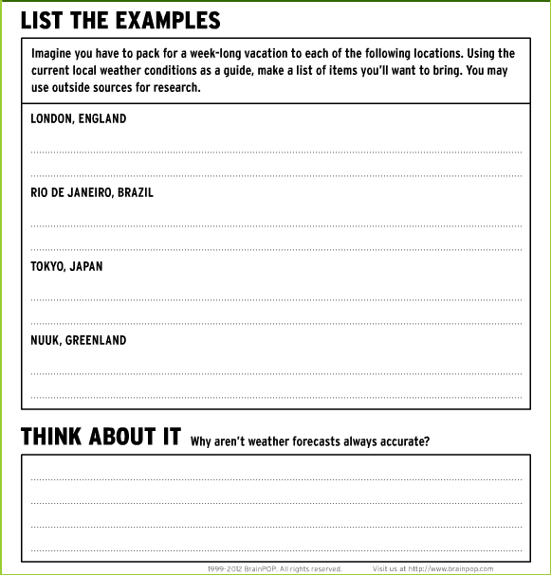
BrainPop Weather Activity

