Name: ________________________________________ Date: _____________
Ms. Williams and Ms. Narracci Science 691/693
Homework: Air Masses
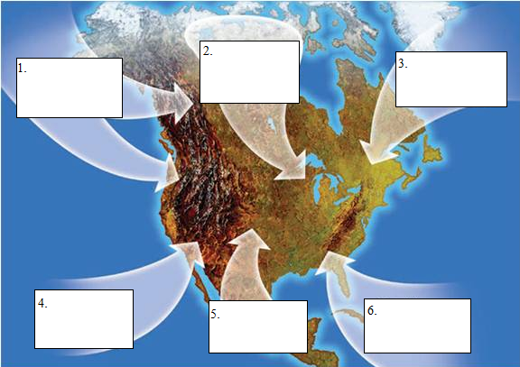
Directions: Label each of the six different air masses affecting weather in the United States on the map. Below the map, explain why you choose that type of air mass of that region.

- ______________________________________________________________________________________________________________________________________________________
- ______________________________________________________________________________________________________________________________________________________
- ______________________________________________________________________________________________________________________________________________________
- ______________________________________________________________________________________________________________________________________________________
- ______________________________________________________________________________________________________________________________________________________
- ______________________________________________________________________________________________________________________________________________________

