Name: ______________________________________ Date: _______________
Ms. Williams and Ms. Narracci Science 693
The Water Cycle and Precipitation
Do Now: Listen to the Water Cycle Rap
“The Water Cycle Rap”

(I rise to the sky from the sea below…)
(Then down to the ground as rain or snow…)

Verse I
I represent the movement of water—that’s my purpose
Whether on, above, or below the earth’s surface
In a continuous cycle, my work’s never done
’Cause I’m driven by energy from the sun
I travel through the sea, through the air, through the ground
You could say that water really gets around
But in fact most water’s just chillin’ in the oceans
Only a small fraction is really in motion at any given time
But yo—that’s the way it goes
When we’re studying the voyages of H2O
In the cycle water changes states at various places
The three states being ice, liquid, and water vapor
But this cycle strays from the norm
‘Cause through the process, water still keeps the same structural form
While other cycles involve chemical change
Water may change states, but its structure stays the same

Chorus
I rise to the sky from the sea below
Then down to the ground as rain or snow
I keep it moving, moving, ’cause I’m the water cycle
Moving, moving, ’cause I’m the water cycle
Verse II
So when water transforms from liquid to gas
And rises up into the atmosphere, that’s evaporation
A process made possible by energy from the sun
Also known as solar radiation
And when this water vapor in the sky reforms
Into liquid water droplets, that’s condensation
And when this water falls back down to the earth
As rain, snow, hail, or sleet, that’s precipitation
But plants have their own type of evaporation
Through their stomata, which is called transpiration
So collectively the term used for transpiration
Plus all other evaporation is evapotranspiration
Two more terms to add to your collection:
The movement of water through the air is advection
And speaking of keeping it moving, understand
That runoff is water flowing across the land

Chorus

You can find this rap at:
http://www.youtube.com/watch?v=i3NeMVBcXX

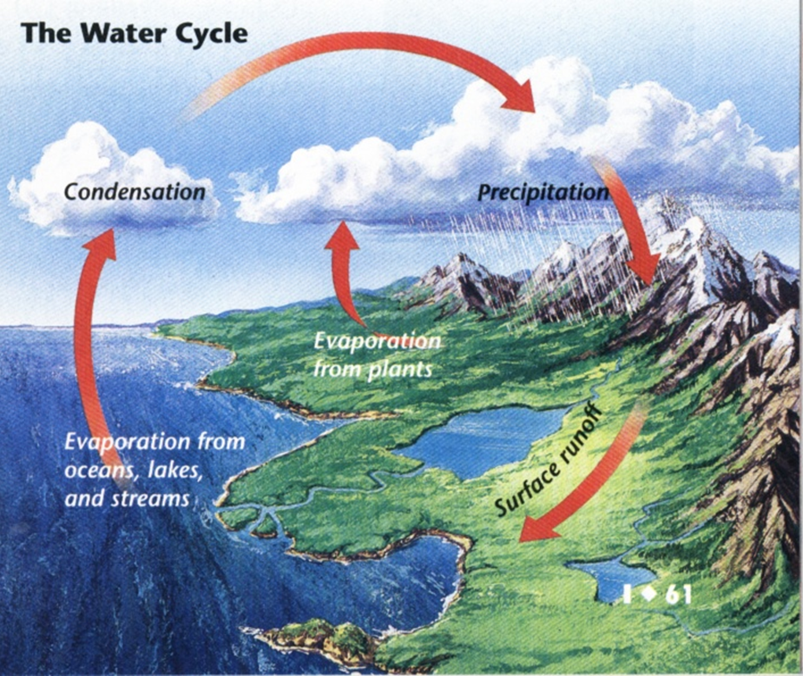
Below is a diagram of the water cycle. Today we will be focusing on precipitation!
Directions: Throughout the class notes will be blanks, be sure to fill in these blanks while we are discussing the topic as a class!
- ___________________ is water falling from the clouds.
- In the air, water vapor condenses around tiny particles, like dust, forming cloud droplets and clouds.
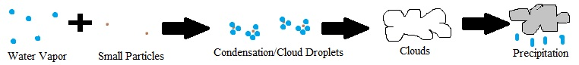
- As these droplets combined and become larger they begin to fall to the Earth.

The ________________ types of precipitation are:
- _____________ occurs when drops of water fall to Earth in __________ freezing temperatures.
Draw Diagram:

- _____________ occurs when the air temperature is so cold that water vapor changes directly to a solid.
Draw Diagram:

- _____________ occurs when rain passes through a layer of freezing air near Earth’s surface forming ice pellets.
Draw Diagram:

- _____________ occurs in cumulonimbus clouds of a thunderstorm when water freezes. Hail grows as it is tossed up and down within the cloud. It can be as large as a _____________________.
Draw Diagram:

Name: __________________________________ Date: _____________
Ms. Williams and Ms. Narracci Science 693
Homework

Directions: For homework, you need to write a paragraph answering the question “How does precipitation occur and what determines the type of precipitation that falls to the Earth?” Below you have the structure of your paragraph. All you have to do is fill in the details using your packet.

All of the water on Earth goes through a continuous cycle, called ________________________________. One major aspect of the ________________________ is________________________________. __________________________ is when water _____________________________________________________________________________. Precipitation is formed when ______________________________________________________
___________________________________________________________________________________________________________________________________________________________. There are ________________ types of precipitation. They are ________________________, _________________________, _____________________________, and __________________ ________________________. Rain is when _________________________________________
_______________________________________________________________________________________________________________. Snow is when _______________________________
_____________________________________________________________________________________________________________. Sleet occurs when ______________________________
________________________________________________________________________________________________. Finally, hail occurs __________________________________________
_____________________________________________________________________________________________________________. ________________ is the most damaging form of precipitation. It can become as large as __________________________________!

