Exit Slip:
In order to leave class today, you must make a tough decision. According to the information you were given in class today answer the following question.
Were the Barbarians as Uncivilized as History depicts them to be?

Barbaric  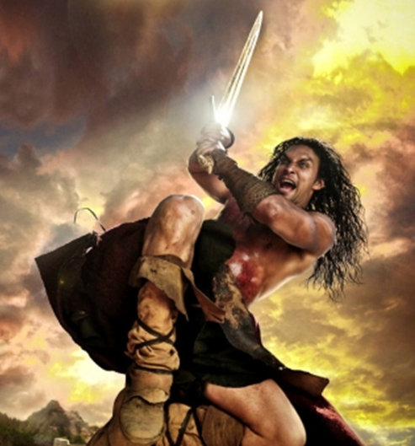 | 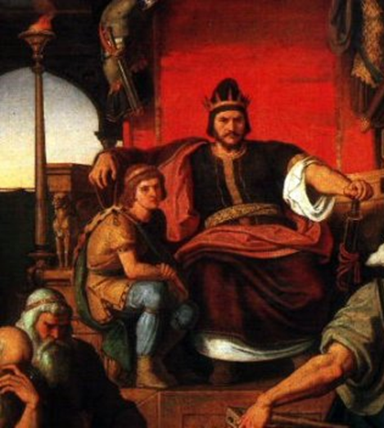  Civilized

__________________________________________________________________________________________________________________________________________________________________________________________________________________________________________________________________________________________________________________________________________________________________________________________________________________________________________________________________________________________________________________________________________________________________________________________________________________________________________________________________________________________________________________________________________________________________________________________________________________________________________________________________________________________________________________________________________________________________________________________________________________________________________________________________________________________

