GRADE SEVEN
The Road to Revolution and Formation of a New Nation

Student Name: _______________________________________
Date: ____________________

Part I: This part contains fifteen multiple choice questions. Record your answers on the separate answer sheets.
Part II: This part consists of two constructed response questions. On this part of the test, you will record your answers to the questions in this test booklet.
Part III: This part consists of three versions of a document based question. On this section, you will be provided with one version of the test based on your readiness to handle critical thinking challenges. (You may opt for a more difficult version than your teacher provides, but you will be graded on the version that you complete.)

Part 1: Multiple Choice Questions
Answer all the questions in this section of the test.

Tier I: Basic
Match the correct definition to each word. (Questions 1-5)
- Enlightenment philosopher that wrote about natural rights of life, liberty and the pursuit of property.
- An event led by Revolutionary War veterans in response to high state taxes.
- The relationship between the national and state government.
- The first direct taxed placed on the American colonists by Great Britain.
- “Shot heard ‘round the world.”

________1. The Stamp Act

________ 2. Lexington and Concord

________ 3. Shay’s Rebellion

________ 4. Federalism

________ 5. John Locke

Tier II: Emerging
________ 6. Which set of events relate to the American Revolution is in the correct chronological order?
A. Intolerable Acts Declaration of Independence Lexington and Concord Treaty of Paris
B. Declaration of Independence Treaty of Paris Intolerable Acts Lexington and Concord
C. Treaty of Paris Declaration of Independence Lexington and Concord Intolerable Acts
D. Intolerable Acts Lexington and Concord Declaration of IndependenceTreaty of Paris
_________ 7. “We the people of the United States of America…”
“All legislative powers herein granted shall be vested in a Congress of the United States, which shall consist of a Senate and a House of Representatives.”
“The Judicial Power of the United States shall be vested in one Supreme Court…”
In which document would these three documents be found?
- The Declaration of Independence
- The Constitution
- The Articles of Confederation
- The Federalist Papers

_________ 8. Decide which heading best fits the following outline.
I._____________________________
1. “Life, liberty and pursuit of property.”
2. The principle of checks and balances
3. Sovereignty should be in the hands of the people.

- Ideas in the Declaration of Independence
- Enlightenment philosophes that influenced the American Revolution
- Ideologies of the Federalist Papers
- All of the Above
_________ 9. The ideals listed below relate to which group in American history:
- Strong Support of States’ Rights
- Opposition to a National Bank
- The economy should be based on agriculture
- France should be our foreign ally

- Federalists
- Whigs
- Know-Nothing Party
- Anti-Federalists
_________ 10. George Washington, 1778 – “Upon a signal given, the whole Army will Huzza! ‘Long Live the King of France.’” After which battle would George Washington most likely have said this?
- Battle of Yorktown
- Battle of Saratoga
- Battle of Trenton
- Battle of Bunker Hill

Tier III: Proficient
________ 11. The ideology of Revolutionary Republicanism…
- Reflected common colonial interests and experiences
- Originated in the struggle of American colonists against imperial despotism
- Borrowed ideas from a variety of former Whig and Enlightenment thinkers
- Provided a coherent doctrine to which all colonists could subscribe
________ 12. “Complaints are everywhere heard from our most considerate and virtuous citizens, equally the friends of public and private faith, and of public and personal liberty, that our governments are too unstable, that the public good is disregarded in the conflicts of rival parties, and that measures are too often decided, not according to the rules of justice and the rights of the minor party, but by the superior force of an interested and overbearing majority. However anxiously we may wish that these complaints had no foundation, the evidence, of known facts will not permit us to deny that they are in some degree true.” – James Madison, Federalist #10
According to the passage, the most dangerous threat to the US Constitution is presented by
- The President’s War Powers
- The Supreme Court
- Political Parties
- The Legislative Branch

________ 13. “We must indeed all hang together, or, most assuredly, we shall all hang separately.”
When Benjamin Franklin said the above quote at the signing of the Declaration of Independence, he was implying that?
- All colonies needed to be unified in order to declare independence.
- The signers of the Declaration of Independence would be hanged for treason if they lost the war.
- The American Revolution was a radical form of rebellion against an imperialistic power.
- All of the above.
________ 14. The excerpt from the poem by Henry Wadsworth Longfellow below discusses Paul Revere’s ride.
He said to his friend, "If the British march
By land or sea from the town to-night,
Hang a lantern aloft in the belfry-arch
Of the North-Church-tower, as a signal-light,--
One if by land, and two if by sea;
And I on the opposite shore will be,
Ready to ride and spread the alarm
Through every Middlesex village and farm,
For the country-folk to be up and to arm."

Based on the poem, what did Paul Revere have to wait for before he warned the colonists about the British Army’s movement?
- The army’s first attack on the colonies.
- A messenger from the South Church.
- A lantern signal.
- A letter from the British commander.

_________ 15.After the French and Indian War, British political leaders were determined to
- Require the North American colonies to pay a greater share of the empire’s administrative expenses.
- End slavery in the North America the North American colonies.
- Encourage colonial expansion into the Ohio River Valley by moving all American Indians people further west.
- Strengthen the French colonial holdings in Canada and the Northwest to discourage Spanish expansion.

Part 2: Constructed Response Questions
Answer all questions in this section of the test.

Directions: Remember to base your answer on the stimulus (picture, map, cartoon, reading, graph, or quote) provided. Write your answers in the spaces provided.
Tier I: Basic
- Base your answers to questions 1-3 on the picture below and on your knowledge of social studies.
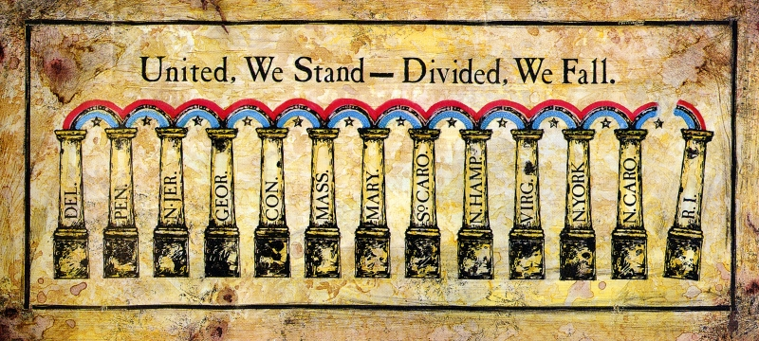

- Based on the picture, what do the pillars represent? [1]
________________________________________________________________________________________________________________________________
- Which event is this picture associated with? [1]
________________________________________________________________________________________________________________________________
- What does the quotation “United, We Stand – Divided, We Fall” mean and why was it important at this time in history? [2]
________________________________________________________________________________________________________________________________________________________________________________________________

Tier 2: Emerging
- Base your answers to questions 4-6 on the newspaper clip below and on your knowledge of social studies.
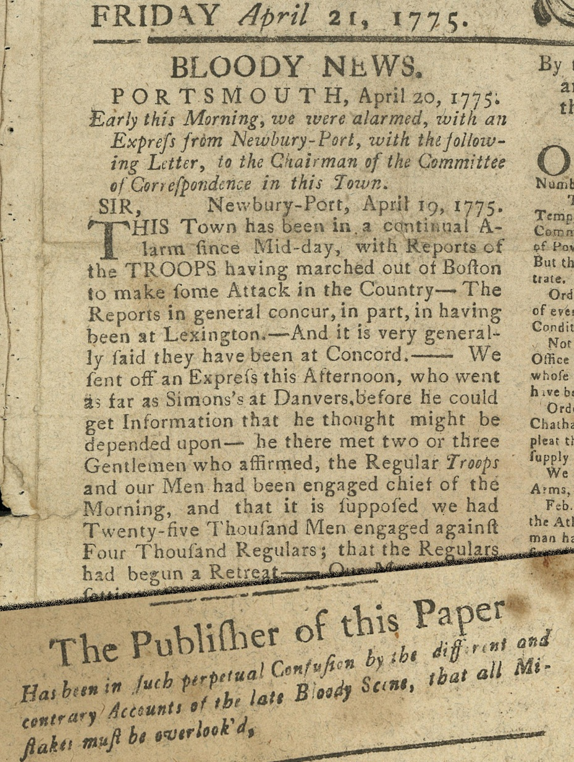

- Based on the document, provide textual evidence for what event has just taken place. [2]
______________________________________________________________________________________________________________________________________________________________________________________________________
- The purpose of the note from the publisher shows what? What were the two viewpoints that emerged in the document? [3]
________________________________________________________________________________________________________________________________________________________________________________________________________________________________________________________________________

- What was the significance of the event that the newspaper article is describing? [2]
________________________________________________________________________________________________________________________________________________________________________________________________________________________________________________________________________

Tier 3: Proficient
- Base your answers to questions 7-9 on the political cartoon depicted below and on your knowledge of social studies.
- What is the overlaying theme of this political cartoon? In which light are the colonists portrayed? [2]
________________________________________________________________________________________________________________________________________________________________________________________________
- What is the significance of the peg-leg? [3]
________________________________________________________________________________________________________________________________________________________________________________________________
- How would you react as a colonist seeing this political cartoon? [2]
________________________________________________________________________________________________________________________________________________________________________________________________

Part 3: Document-Based Questions

Directions: This question is based on the accompanying documents. The question is designed to test your ability to work with historical documents. Some of these documents have been edited for the purposes of this question. As you analyze the documents, take into account the source of each document and any point of view that may be presented in the document.

Historical Context:
The 17th and 18th centuries Europe saw a new age in thinking, called the Enlightenment. During this era, many new thoughts emerged about the organization of the government and societal reforms. Leaders of this movement, such as John Locke claimed people had unalienable rights of life, liberty, and the pursuit of property. Today, these principles are thought to influence the development of democracies around the world.

Task: Using the information from the documents and your knowledge of United States history, answer the questions that follow each document in Part A. Your answers to the questions will help you write the Part B essay in which you will be asked to:

Using both your own knowledge and the documents provided:
- Discuss two events or principles in the American Revolution that were shaped by the Enlightenment principles?
- Discuss two principles in the American government that were shaped by the Enlightenment principles?
- Evaluate the extent to which the American Revolution and the American government that followed were built on the foundation created in the Enlightenment principles?

Part A: Short-Answer Questions

Directions: Analyze the documents and answer the short-answer questions that follow in the space provided.

Enlightenment Thinkers | Their Ideals
John Locke | - Natural rights: Life, Liberty and Pursuit of Property.  - Government is created to protect the people’s natural rights.
Jean-Jacques Rousseau | - “Man is born free, and everywhere he is in chains.”  - Believes in democracy – people must give up certain rights for the common good and preservation of other rights.
Baron de Montesquieu | - Separation of Powers  - Checks and Balances
Voltaire | - Freedom of religious, thought and expression.
Thomas Hobbes | - Man are born equal  - In the state of nature, life is “short, nasty and brutish.”  - Need government to control man.

Tier 1: Basic

Document 1:
Engraving by Paul Revere
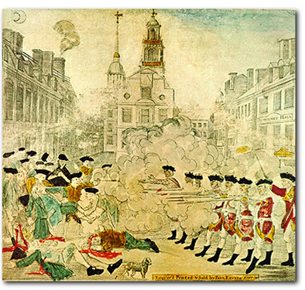

On March 5, 1770 crowds gathered in the streets of Boston. British troops had been sent into the city to enforce the Townsend Acts. The troops were being tormented by colonists in response to the growing anger among them for the troops’ presence. The troops fired into the crowd as a response, killing five unarmed colonists. This event was a result of the growing tensions between Great Britain and the American Colonies.

- According to the document, what is occurring in this picture? [1]
____________________________________________________________________________________________________________________________________

Document 2:
SOURCE: George Hewes, 1773 - Firsthand America, A History of the United States, David Burner, 1996.

One the evening of December 16, 1773, a gathering of perhaps 8,000 men, much of the town’s contingent [group] of able-bodies males, assembled at the Old South Church. They were there to hold a town meeting, to ask that the hated tea not be landed. Their request was not granted, and at the end of the meeting Sam Adams rose from his seat and said, "This meeting can do nothing to save the country." As if by prearranged signal, as soon as the meeting adjourned [ended], a band of men disguised as Mohawk Indians rushed down Milk Street to Griffin’s Wharf. Three companies of these instant Indians rowed out to the anchored tea ships, boarded them, split open the tea chests, and dumped their massive contents into the waters of the harbor. Their mission accomplished, the men quickly and quietly dispersed...."

- According to the document, what event occurred on December 16, 1773? [1]
____________________________________________________________________________________________________________________________________

- Using evidence from the document, what did the colonists dress up as to disguise themselves and what actions were carried out on the ships? [2]
________________________________________________________________________________________________________________________________________________________________________________________________________________________________________________________________________

Document 3:
First Continental Congress -October 1774
Resolved, That the following acts of Parliament are violations [took away] of the rights of the colonists; and that the repeal [removal] of them is essentially necessary, in order to restore harmony [a positive relationship] between Great Britain and the American colonies, viz.:
The several Acts [Stamp Act, Sugar Act, Townsend Acts, etc.] which impose duties [taxes] for the purpose of raising a revenue [money] in America, extend powers of the admiralty courts beyond their ancient limits [Parliament], deprive the American subject of trial by jury …and are subversive [go against] of American rights.
- According to the document, the only way to restore harmony between the Colonies and Great Britain, what needs to occur? [1]
____________________________________________________________________________________________________________________________________
- Enlightenment thinker John Locke stated that government was created to protect the rights of the people, therefore, according to the document, are the colonists justified for wanting to break away from Great Britain? [2]
________________________________________________________________________________________________________________________________________________________________________________________________________________________________________________________________________

Document 4:
SOURCE: Declaration of Independence

We hold these truths to be self-evident [obvious], that all men are created equal, that they are endowed [given] by their Creator God] with certain unalienable [natural] Rights, that among these are Life, Liberty and the pursuit of Happiness.--That to secure these rights, Governments are instituted among Men[ created by the people], deriving [gaining] their just powers from the consent of the governed [the people], --That whenever any Form of Government becomes destructive of these ends [ tyrannical], it is the Right of the People to alter or to abolish it, and to institute [put in place] new Government, laying its foundation on such principles and organizing its powers in such form, as to them shall seem most likely to effect their Safety and Happiness.

- According to the document, what rights do all men have? From what movement did Thomas Jefferson get these ideas? [2]
____________________________________________________________________________________________________________________________________

- The document states that if a government becomes too oppressive it is the right of the people to do what? [1]
______________________________________________________________________________________________________________________________________________________________________________________________________

Document 5:
SOURCE: A Letter from George Washington to a friend addressing the weaknesses of the Articles of Confederation.
“The consequences [effects] of a . . . [an] inefficient [weak] government are too obvious to be dwelt upon. Thirteen sovereignties [individual governments] pulling against each other, and all tugging at the federal head, will soon bring ruin upon the whole. . . . Let us have [government] by which our lives, liberty, and property will be secured or let us know the worst at once.”
- According to the document, what will bring ruin upon the new nation of the United States? [1]
____________________________________________________________________________________________________________________________________
- George Washington calls for what in order to preserve our lives, liberty, and property? Using which principles would these rights be guarded under? [2]
______________________________________________________________________________________________________________________________________________________________________________________________________

Document 6:
SOURCE: Letter from George Washington informing Congress of the proceedings of the Constitutional Convention on September 17, 1787
The friends of our country have long seen and desired that the power of making war, peace, and treaties, that of levying money [taxes], and regulating commerce, and the correspondent executive and judicial authorities, should be fully and effectually vested in the General Government of the Union; but the impropriety [problems] of delegating such extensive trust to one body of men is evident: hence results the necessity of a different organization.
It is obviously impracticable [unrealistic] in the Federal Government of these States to secure all rights of independent sovereignty [individual governments] to each, and yet provide for the interest and safety of all. Individuals entering into society must give up a share of liberty to preserve the rest. The magnitude [scale] of the sacrifice must depend as well on situation and circumstance, as on the object to be obtained. It is at all times difficult to draw with precision the line between those rights which must be surrendered, and those which may be preserved; and, on the present occasion, this difficulty was increased by a difference among the several States as to their situation, extent, habits, and particular interests.
- According to the document, what are the colonists unwilling to give to one body of men? What principles should the government follow to help gain the trust of the people? Why would these principles help? [3]
________________________________________________________________________________________________________________________________________________________________________________________________________________________________________________________________________
- The document asks individuals entering into society to give up what in order to preserve the union? What is difficult about this? [2]
________________________________________________________________________________________________________________________________________________________________________________________________________________________________________________________________________
Part A: Short-Answer Questions

Directions: Analyze the documents and answer the short-answer questions that follow in the space provided.

Focus your attention on:
- Evaluate the extent to which the American Revolution was built on the foundation created in the Enlightenment principles?
- Evaluate the extent the American government that followed the Revolution was built on the foundation created in the Enlightenment principles?

Enlightenment Thinkers | Their Ideals
John Locke | - Natural rights: Life, Liberty and Pursuit of Property.  - Government is created to protect the people’s natural rights.
Jean-Jacques Rousseau | - “Man is born free, and everywhere he is in chains.”  - Believes in democracy – people must give up certain rights for the common good and preservation of other rights.
Baron de Montesquieu | - Separation of Powers  - Checks and Balances
Voltaire | - Freedom of religious, thought and expression.
Thomas Hobbes | - Man are born equal  - In the state of nature, life is “short, nasty and brutish.”  - Need government to control man.

Tier 2: Emerging

Document 1:
Engraving by Paul Revere of the streets of Boston, Massachusetts on March 5, 1770.

- The document depicts which event that was one cause in the road to the Revolutionary War? What was the Colonists’ response? [2]
____________________________________________________________________________________________________________________________________
__________________________________________________________________

Document 2:
SOURCE: George Hewes, 1773 - Firsthand America, A History of the United States, David Burner, 1996.

One the evening of December 16, 1773, a gathering of perhaps 8,000 men, much of the town’s contingent [group] of able-bodies males, assembled at the Old South Church. They were there to hold a town meeting, to ask that the hated tea not be landed. Their request was not granted, and at the end of the meeting Sam Adams rose from his seat and said, "This meeting can do nothing to save the country." As if by prearranged signal, as soon as the meeting adjourned [ended], a band of men disguised as Mohawk Indians rushed down Milk Street to Griffin’s Wharf. Three companies of these instant Indians rowed out to the anchored tea ships, boarded them, split open the tea chests, and dumped their massive contents into the waters of the harbor. Their mission accomplished, the men quickly and quietly dispersed...."

- According to the document, what event occurred on December 16, 1773? Why did this event occur, what did the colonists feel was being violated? What was Great Britain’s response to this act? [4]
__________________________________________________________________________________________________________________________________________________________________________________________________________________________________________________________________________________________________________________________________________

Document 3:
First Continental Congress -October 1774
Resolved, That the following acts of Parliament are violations [took away] of the rights of the colonists; and that the repeal [removal] of them is essentially necessary, in order to restore harmony [a positive relationship] between Great Britain and the American colonies, viz.:
The several Acts [Stamp Act, Sugar Act, Townsend Acts, etc.] which impose duties [taxes] for the purpose of raising a revenue [money] in America, extend powers of the admiralty courts beyond their ancient limits [Parliament], deprive the American subject of trial by jury …and are subversive [go against] of American rights.

- After hearing the grievances of the colonists listed above, the King of England brushed them aside. According to the Enlightenment philosopher, John Locke who states that government is formed to protect the rights of the people, what actions should the colonists take and why? [3]
__________________________________________________________________________________________________________________________________________________________________________________________________________________________________________________________________________________________________________________________________________

Document 4:
SOURCE: Declaration of Independence

We hold these truths to be self-evident [obvious], that all men are created equal, that they are endowed [given] by their Creator God] with certain unalienable [natural] Rights, that among these are Life, Liberty and the pursuit of Happiness.--That to secure these rights, Governments are instituted among Men[ created by the people], deriving [gaining] their just powers from the consent of the governed [the people], --That whenever any Form of Government becomes destructive of these ends [ tyrannical], it is the Right of the People to alter or to abolish it, and to institute [put in place] new Government, laying its foundation on such principles and organizing its powers in such form, as to them shall seem most likely to effect their Safety and Happiness.

- The document states that if a government becomes too oppressive it is the right of the people to do what? What movement did Thomas Jefferson gain these ideas from? [3]
__________________________________________________________________________________________________________________________________________________________________________________________________________________________________________________________________________________________________________________________________________

Document 5:
SOURCE: A Letter from George Washington to a friend addressing the weaknesses of the Articles of Confederation.
“The consequences [effects] of a . . . [an] inefficient [weak] government are too obvious to be dwelt upon. Thirteen sovereignties [individual governments] pulling against each other, and all tugging at the federal head, will soon bring ruin upon the whole. . . . Let us have [government] by which our lives, liberty, and property will be secured or let us know the worst at once.”
- A government which protects the unalienable rights of the people, such as the one George Washington is describing, embodies which movement? Explain. [2]
________________________________________________________________________________________________________________________________________________________________________________________________________________________________________________________________________

Document 6:
SOURCE: Letter from George Washington informing Congress of the proceedings of the Constitutional Convention on September 17, 1787
The friends of our country have long seen and desired that the power of making war, peace, and treaties, that of levying money [taxes], and regulating commerce, and the correspondent executive and judicial authorities, should be fully and effectually vested in the General Government of the Union; but the impropriety [problems] of delegating such extensive trust to one body of men is evident: hence results the necessity of a different organization.
It is obviously impracticable [unrealistic] in the Federal Government of these States to secure all rights of independent sovereignty [individual governments] to each, and yet provide for the interest and safety of all. Individuals entering into society must give up a share of liberty to preserve the rest. The magnitude [scale] of the sacrifice must depend as well on situation and circumstance, as on the object to be obtained. It is at all times difficult to draw with precision the line between those rights which must be surrendered, and those which may be preserved; and, on the present occasion, this difficulty was increased by a difference among the several States as to their situation, extent, habits, and particular interests.
- According to the document, what are the difficulties in establishing a more unified government in the United States? Following which principles would make this process easier? Why? [4]
______________________________________________________________________________________________________________________________________________________________________________________________________________________________________________________________________________________________________________________________________________________________________________________________________________________________________________________________________________

Part A: Short-Answer Questions

Directions: Analyze each document. Make sure to take notes when analyzing each document in order to answer the DBQ essay question.

Focus your attention on:
- Evaluate the extent to which the American Revolution and the American government that followed were built on the foundation created in the Enlightenment principles?

Enlightenment Thinkers | Their Ideals
John Locke | - Natural rights: Life, Liberty and Pursuit of Property.  - Government is created to protect the people’s natural rights.
Jean-Jacques Rousseau | - “Man is born free, and everywhere he is in chains.”  - Believes in democracy – people must give up certain rights for the common good and preservation of other rights.
Baron de Montesquieu | - Separation of Powers  - Checks and Balances
Voltaire | - Freedom of religious, thought and expression.
Thomas Hobbes | - Man are born equal  - In the state of nature, life is “short, nasty and brutish.”  - Need government to control man.

Tier 3: Proficient

Document 1:
Engraving by Paul Revere

Document 2:
SOURCE: George Hewes, 1773 - Firsthand America, A History of the United States, David Burner, 1996.

One the evening of December 16, 1773, a gathering of perhaps 8,000 men, much of the town’s contingent [group] of able-bodies males, assembled at the Old South Church. They were there to hold a town meeting, to ask that the hated tea not be landed. Their request was not granted, and at the end of the meeting Sam Adams rose from his seat and said, "This meeting can do nothing to save the country." As if by prearranged signal, as soon as the meeting adjourned [ended], a band of men disguised as Mohawk Indians rushed down Milk Street to Griffin’s Wharf. Three companies of these instant Indians rowed out to the anchored tea ships, boarded them, split open the tea chests, and dumped their massive contents into the waters of the harbor. Their mission accomplished, the men quickly and quietly dispersed...."

Document 3:
First Continental Congress -October 1774
Resolved, That the following acts of Parliament are violations [took away] of the rights of the colonists; and that the repeal [removal] of them is essentially necessary, in order to restore harmony [a positive relationship] between Great Britain and the American colonies, viz.:
The several Acts [Stamp Act, Sugar Act, Townsend Acts, etc.] which impose duties [taxes] for the purpose of raising a revenue [money] in America, extend powers of the admiralty courts beyond their ancient limits [Parliament], deprive the American subject of trial by jury …and are subversive [go against] of American rights.

Document 4:
SOURCE: Declaration of Independence

We hold these truths to be self-evident [obvious], that all men are created equal, that they are endowed [given] by their Creator God] with certain unalienable [natural] Rights, that among these are Life, Liberty and the pursuit of Happiness.--That to secure these rights, Governments are instituted among Men[ created by the people], deriving [gaining] their just powers from the consent of the governed [the people], --That whenever any Form of Government becomes destructive of these ends [ tyrannical], it is the Right of the People to alter or to abolish it, and to institute [put in place] new Government, laying its foundation on such principles and organizing its powers in such form, as to them shall seem most likely to effect their Safety and Happiness.

Document 5:
SOURCE: A Letter from George Washington to a friend addressing the weaknesses of the Articles of Confederation.
“The consequences [effects] of a . . . [an] inefficient [weak] government are too obvious to be dwelt upon. Thirteen sovereignties [individual governments] pulling against each other, and all tugging at the federal head, will soon bring ruin upon the whole. . . . Let us have [government] by which our lives, liberty, and property will be secured or let us know the worst at once.”

Document 6:
SOURCE: Letter from George Washington informing Congress of the proceedings of the Constitutional Convention on September 17, 1787
The friends of our country have long seen and desired that the power of making war, peace, and treaties, that of levying money [taxes], and regulating commerce, and the correspondent executive and judicial authorities, should be fully and effectually vested in the General Government of the Union; but the impropriety [problems] of delegating such extensive trust to one body of men is evident: hence results the necessity of a different organization.
It is obviously impracticable [unrealistic] in the Federal Government of these States to secure all rights of independent sovereignty [individual governments] to each, and yet provide for the interest and safety of all. Individuals entering into society must give up a share of liberty to preserve the rest. The magnitude [scale] of the sacrifice must depend as well on situation and circumstance, as on the object to be obtained. It is at all times difficult to draw with precision the line between those rights which must be surrendered, and those which may be preserved; and, on the present occasion, this difficulty was increased by a difference among the several States as to their situation, extent, habits, and particular interests.

Part B: Essay

Directions: Write a well-organized essay that includes an introduction, several paragraphs, and a conclusion. Use evidence from at least four documents in your essay. Support your response with relevant facts, examples, and details. Include additional outside information.

Historical Context:
The 17th and 18th centuries Europe saw a new age in thinking, called the Enlightenment. During this era, many new thoughts emerged about the organization of the government and societal reforms. Leaders of this movement, such as John Locke claimed people had unalienable rights of life, liberty, and the pursuit of property. Today, these principles are thought to influence the development of democracies around the world.

Task: Using the information from the documents and your knowledge of United States history, answer the questions that follow each document in Part A. Your answers to the questions will help you write the Part B essay in which you will be asked to:
Using both your own knowledge and the documents provided:
- Discuss two events or principles in the American Revolution that were shaped by the Enlightenment principles?
- Discuss two principles in the American government that were shaped by the Enlightenment principles?
- Evaluate the extent to which the American Revolution and the American government that followed were built on the foundation created in the Enlightenment principles?

Guidelines:
In your essay, be sure to
- Develop all aspects of the task
- Incorporate information from at least four documents
- Incorporate relevant outside information
- Support the theme with relevant facts, examples, and details
- Use a logical and clear plan of organization, including an introduction and a conclusion that are beyond a restatement of the theme

