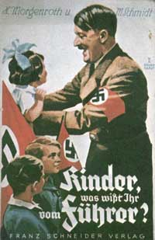

“...the personification of the devil as the symbol
of all evil assumes the living shape of the Jew.”

“The heaviest blow which ever struck humanity was Christianity; Bolshevism is Christianity’s illegitimate child. Both are inventions of the Jew.”
“We want this people to be faithful, and you must learn fidelity. We want this people to be obedient, and you must practice obedience. We want this people to be peace-loving but also courageous, and you must therefore be peace-loving and at the same time courageous. We do not want this people to grow soft, but we want it to be hard so that it will be able to withstand the hardships of life. And for this you have to harden yourselves in your youth. You must learn to be hard, to stand privations without breaking down. We want this people to love honor and you already in the days of your youth must live up to this concept of honor”

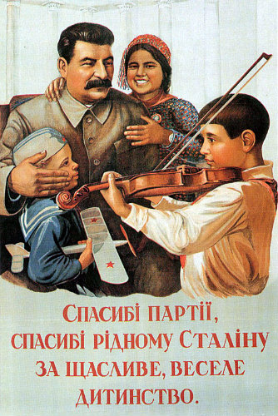
Thank you Stalin for our happy childhood
“We do not want a single foot of foreign territory; but of our territory we shall not surrender a single inch to anyone.”
“It is enough that the people know there was an election. The people who cast the votes decide nothing. The people who count the votes decide everything.”
“In the Soviet army it takes more courage to retreat than advance.”
“Stalin stated that after Communism succeeds, “. . . then, there will come a peace across the earth.”
"When we hang the capitalists they will sell us the rope we use."

“The law of selection justifies this incessant struggle, by allowing the survival of the fittest. Christianity is a rebellion against natural law, a protest against nature. Taken to its logical extreme, Christianity would mean the systematic cultivation of the human failure.”
“What we have to fight for…is the freedom and independence of the
fatherland, so that our people may be enabled to fulfill the mission
assigned to it by the Creator.”

