What I KNOW. | What I WANT to know. | What I LEARNED.
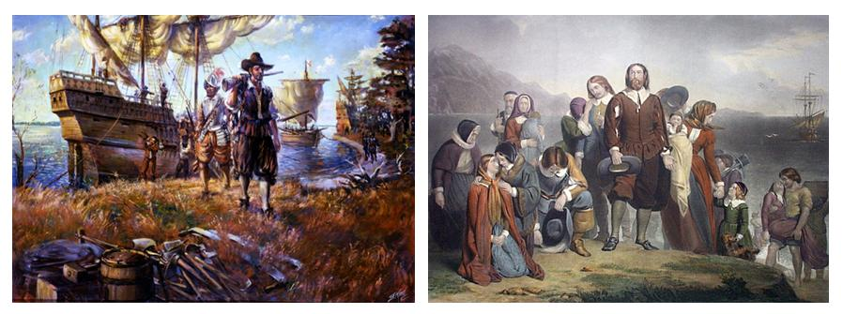
Jamestown and Plymouth Colonies

