Colonial Life on Long Island and the Development of Slavery

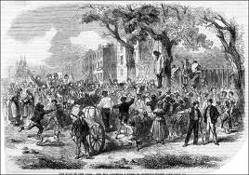
“The lives of slaves on Long Island are not so bad. It’s not like in the South. And besides, we don’t have that much slavery here anyway...” – A statement made by a White male 46 year old farmer made sometime during the mid-1700s.

The Set Up of Colonial Long Island
The first Europeans to come to Long Island were Henry Hudson and his crew in 1609. However, these men were looking for a water route to India, so they did not stay and settle the region. Then in 1614, Adrian Block from Holland sailed around the island and named it Long Island due to its length. In the same year, the Dutch West India Company sent five ships to Manhattan to establish a trading post in order to trade fur with the Native Americans. In 1635, Long Island became divided between the English and the Dutch, when King Charles I of England gave Long Island to the Earl of Sterling.
The first settlers on Long Island were Dutch. They established the town of New Amsterdam, which they bought from the Manhattan tribe. The Dutch settlements were established between 1636 and 1660. The English began settling eastern Long Island in the 1640’s. By 1650 the Dutch and English divided Long Island in the Treaty of Hartford. The western half was given to the Dutch and the eastern half was given to the English. The Dutch settlements focused on trading while the British focused on building settlements. The Dutch introduced slavery to Long Island in 1626. The English soon started using the slaves for labor as well.
In March of 1664, King Charles II of England gave Long Island to the Duke of York. By August 1664, the English forced the Dutch to give up land claims in New Amsterdam, and created the colony of New York. The population was made up mostly of farmers and jobs associated with the agricultural community. The main crops grown on Long Island were grain, tobacco, pumpkins, and melons. They also had livestock such as hogs, sheep, cattle, and horses. In addition to farming, Long Island had a big fishing and whaling industry. Fishermen caught clams, oysters, fish, and crabs, while whales were used to make oil.

1. Statement: New York was originally a Dutch trading post set up by the Dutch West India Company.

________Agree __________Disagree
Evidence:__________________________________________________________________________________________________________________________________________________________________________________________________________________________________

2. Statement: Slavery made the work of farmers, fisherman, and whalers easier.

_________Agree _________Disagree
Evidence:__________________________________________________________________________________________________________________________________________________________________________________________________________________________________

3. Statement: If you lived on Long Island in colonial times you would’ve had slaves.

________Agree __________Disagree
Evidence:__________________________________________________________________________________________________________________________________________________________________________________________________________________________________

Native Americans on Long Island
Prior to Long Island being settled by Europeans, Native Americans occupied the land. The Native Americans had been here for at least 9,000 years before the European settlements began being formed. These Natives were members of the Algonquin tribe, and lived in thirteen communities throughout Long Island. The Algonquin were known as peaceful people.
The Algonquin were hunters, fishers, and farmers. They excelled at whale hunting, fishing and deer hunting since these animals supported their ways of life. Besides the animals they hunted, they also grew corn, beans, squash and pumpkins.
The relationship between the Native Americans and European settlers were initially good. The Natives normally sold land to the Dutch and English, such as the island of Manhattan. Also, many of the Natives worked for the European settlers, especially as whale hunters. However, some Europeans turned the Natives into their slaves. The Natives knew how to farm the land and had already become excellent whale hunters and fisherman so making them slaves seemed more beneficial than paying them for labor to the Europeans.
Many of the Natives died from diseases that Europeans brought to the New World or were able to escape due to their knowledge of the land. Therefore, Natives did not make excellent slaves. The European settlers realized this and started to import African American slaves to New York. By 1679, New York State forbade the slavery of Native Americans, but the practice seemed to continue in parts of New York illegally until 1827.

- Statement: Europeans settled the land prior to the Native Americans.

_________Agree __________Disagree
Evidence:__________________________________________________________________________________________________________________________________________________________________________________________________________________________________

- Statement: The peaceful ways of the Algonquin led to good relationships with Europeans initially.

__________Agree __________Disagree
Evidence:__________________________________________________________________________________________________________________________________________________________________________________________________________________________________

- Statement: African Americans were stronger slaves than Native Americans slaves.

___________Agree _________Disagree
Evidence:__________________________________________________________________________________________________________________________________________________________________________________________________________________________________

Fishing and Whaling Industries on Long Island
Native Americans were the first whalers on Long Island. The used the whales for oil, bone and flesh. The whale oil also became an important resource for European settlers on Long Island. Early on, Europeans hired Native Americans to hunt whales for them in return for goods. However, the Europeans began to resent the high prices paid to Native Americans.
Whaling was a popular industry in the New England colonies and it was brought to Long Island by settlers leaving the New England colonies and settling on Long Island in the 1640’s. These Europeans made whaling a regular business on Long Island, and took the business away from the Natives. Soon many European whaling companies, such as the East Hampton Company, were formed.
The ships manned by six men would have long and hard struggles in order to catch a whale. After they had successfully caught the whale, the whales would be hauled up on shore. Then the whale’s bone and blubber or fat would be cut out. The blubber is what was boiled down into oil. This oil was sold for a large amount of money by the whalers. Whale oil was used in lamps and candles. Its production was essential to Long Islanders since its revenue was used to pay their debts and taxes. Whale hunting was so important to Long Islanders that children even had off from school from December to April for whaling season.
Fishing was also a major industry on Long Island in colonial times. Many fishermen earned their living by harvesting shellfish off of the East End of Long Island. Montauk, Sag Harbor and the Hamptons were large fishing towns. However, due to many factors Long Island’s fishing industry has collapsed in recent times.

- Statement: Europeans resented paying high prices to Native Americans for whaling.
__________Agree __________Disagree
Evidence:__________________________________________________________________________________________________________________________________________________________________________________________________________________________________

- Statement: Whaling became a larger industry on Long Island due to the influx of settlers from the New England colonies.
__________Agree __________Disagree
Evidence:__________________________________________________________________________________________________________________________________________________________________________________________________________________________________

- Statement: The increase in the whaling industry weakened relationships between Native Americans and European settlers on Long Island.
__________Agree ___________Disagree
Evidence:__________________________________________________________________________________________________________________________________________________________________________________________________________________________________

Slavery on Long Island
Slavery began on Long Island in 1626 when the Dutch West India Company purchased eleven African Americans slaves to be used on public projects and in defense of the New Amsterdam colony. These men were initially considered to be indentured servants but eventually were labeled as property and servants for life.
During colonial times, New Yorkers owned more slaves then all New England colonies combined. By 1698, there were about 2,130 African American slaves in the colony, half of which lived on Long Island. Slavery became increasingly popular on Long Island due to the increasing demand for labor which was attributed to the available land decreasing. As the available land decreased, many European laborers decided against working on existing farms and grabbed at the opportunity to own their own land.
Slavery on Long Island took on a different look then slavery in the Southern colonies. Most slave-owners on Long Island were small farmers who only used one to three slaves to work their smaller farms. Very few families owned more slaves than that. Also, due to the smaller farms, slaves normally lived in their masters’ houses instead of separate slave quarters.
Slaves on Long Island were multi-occupational. They worked on farms and other industries such as tailoring or whaling. Female slaves were normally designated as the domestic servant and cooked and cared for the masters and their children. These slaves even worked beside paid European workers, indentured servants and sometimes even their slave-owners. However, despite the different set up of slavery on Long Island, the slave codes were just as harsh. An example is shown when in March 1741. Thirteen slaves were burned at the stake after being blamed for starting a fire on Long Island although there was no evidence against them.

- Statement: Out of the 2,130 slaves in the New York colony, half of them lived on Long Island.
_________Agree _________Disagree
Evidence:__________________________________________________________________________________________________________________________________________________________________________________________________________________________________

- Statement: Slaves on Long Island worked in many different industries.

_________Agree _________Disagree
Evidence:__________________________________________________________________________________________________________________________________________________________________________________________________________________________________

- Statement: Life would be easier being a slave on Long Island as opposed to being a slave in the Southern colonies.
_________Agree _________Disagree
Evidence:__________________________________________________________________________________________________________________________________________________________________________________________________________________________________

Exit Slip:
In order to leave class today, you must make a tough decision. According to the information you were given in class today answer the following question.
Which industry do you think most effected the development of slavery on Long Island? Farming, Whaling, Fishing, or Public Works? Why?

Farming | Whaling  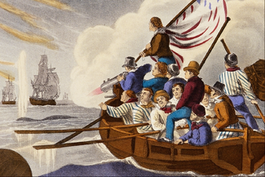
Fishing  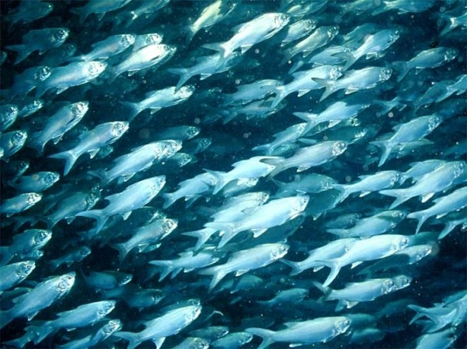 | Public Works  



