Name:____________________________ Date:_____________

Religion in Jamestown
The Jamestown settlement was not found on the ground of escaping religious persecution. Jamestown was a business plan organized to profit English investors by the Virginia Company, named after the Virgin Queen, Elizabeth I. Members of the Virginia Company and Jamestown settlers were members of the Church of England. If any were under Puritan influence, they were not Separatists and remained conforming members of the Church of England.
In 1607 the Jamestown settlers celebrated communion shortly after landing. One of the first settlers was actually an Anglican Minister.
However, during the reigns of King James and King Charles, England was engulfed in the Puritan revolution. During this time Jamestown remained loyal to the King and the settlers remained conforming members of the Church of England even as the church underwent profound change in England.
What is the Anglican Church or Church of England?
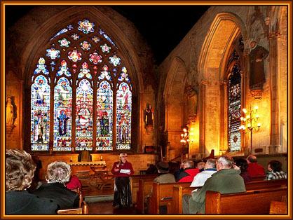
The Church of England was created in 1538, under the reign of King Henry VIII. The creation of the Church of England broke the English’s ties with the Pope in Rome and Roman Catholicism. Today the Church of England is still headed by the Archbishop of Canterbury, who lives in England.

Religion in Massachusetts Bay
Pilgrims were Puritans who wished to separate themselves from the Church of England because they found its practices and doctrines heretical to Calvinists principles. Due to actions based on these beliefs, they were persecuted in England and fled to Holland, and then to the Colonies.
Pilgrims selected their minister, elder and deacons. Nonetheless the minister had to be ordained to administer the sacraments of baptism and communion. The Pilgrims were a conservative community agreeing to defend and live in accordance with Calvinist principles. These principles sustained them in exile, during the stressful Atlantic crossing and the horrific early months of 1621 when half of the settlers died.
Once landed in Plymouth, some settlers wants to continue on to Jamestown, while others wanted to remain in Massachusetts Bay and prepare for winter. The issue resolved by drafting the Mayflower Compact, similar to their Puritan pledge, but for political purposes, which all free adult men signed on November 11, 1620. The document stated how they would conduct themselves as a political body and it remained the basis for governance for nearly 70 years.
What is Calvinism?
Calvinism is the religion founded on the beliefs of John Calvin. A major part of Calvinism was the belief in predestination. Predestination states that God has already determined whether or not we go to heaven, therefore we must live our lives around God and his laws in case we are supposed to go to heaven.
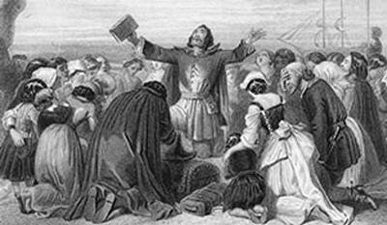
The Pilgrims followed the Calvinist ideas and thought the Church of England was still too connected to the practices of the Roman Catholic Church. The Pilgrims wanted to purify the Church of England and were therefore persecuted.

Name:____________________________ Date:_____________

The Leaders of the New Colonies
John Smith (1580-1631)
The most influential person in the early years of Jamestown was Captain John Smith. Smith was born to a Lincolnshire farm family in 1580 but orphaned at the age of 13. Within a few years he enlisted in the English army and fought in the Netherlands in its war of independence from Spain. Following this he enlisted in the Austrian army and fought against the Turks. In 1602 he was captured in a battle in Hungary, escaped a year later and returned to England. The Virginia Company hired Smith to manage the colony's military activities with the Indians and Spanish.
In Jamestown he organized expeditions to explore the wilderness and traded skillfully with the Indians for food. As a soldier he had experience dealing with foreigners, both as allies and enemies and knew the importance of learning to converse in the foreigner's language, leading to Smith learning to speak the Indian's language.
Smith's practical nature led him to impose discipline upon colonists. In 1609 he was elected colony president. However, Smith was injured and in October 1609, he was recalled to England by the Virginia Company and never to set foot in Virginia again. Back in England, Smith tried to return to England but was unable to.
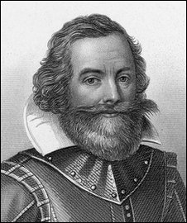

William Bradford (1590-1657)
William Bradford was born to a prosperous, four-generation, land-owing, farming family in Lincolnshire. He was orphaned at the age of 7 and raised first by his grandfather and then his uncles. He was taught to read by the local minister and introduced to the classics in his library.
By the age of 12 he was drawn to the Puritan reform movement preached by Richard Clyfton and John Robinson in the nearby town of Babworth. Bradford became friends with the 37-year old Cambridge-educated William Brewster, postmaster in nearby Scrooby who was also drawn to the Puritan reform movement. In 1608 Bradford and Brewster fled to Holland with John Robinson's congregation and in time they became leaders of the congregation.
Bradford rose to distinction in 1612 to become a leader in commerce, a citizen of Leiden and member in a guild (trade union). Bradford along with John Carver, William Brewster and Robert Cushman decided which members of the congregation would make the trip to North America. Upon arriving at the Massachusetts Bay Colony in November 1620, Carver, Bradford and Brewster composed the Mayflower Compact.
These difficult negotiations were the first of many Bradford undertook to maintain peace with the Native Americans and mediate differences in the colony. In April 1621 Bradford was elected Governor of the Plymouth colony when John Carver died.

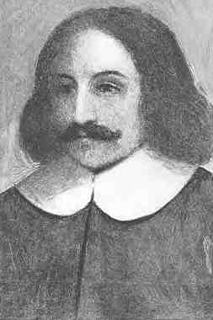

Name:____________________________ Date:_____________

Neighboring Native Americans
Powhatan Indians
Jamestown was located in the lands of the Tsenacommacah nation of Algonquian Indians in eastern Virginia. The chief of over two dozen tribes in the nation was called Powhatan by the settlers.
The Indians enjoyed peace for many years prior to the arrival of the English, and while cautious in their relationship with settlers, did not fear them. Hostile Europeans who landed in North America decades before 1607 were common knowledge among the Indians. Indians respected strength they believed Europeans had and were awed by their firearms. Nonetheless they tested the settler's strength whenever possible.
Settlers sometimes stole Indian corn and Indians sometimes stole English farm tools. Such theft occasionally led to retaliation resulting in the loss of life on both sides. After the departure of John Smith the Jamestown leaders fluctuated between peace, when the Indians took advantage of them in trade, or retaliation, resulting in cruel killing of Indians.
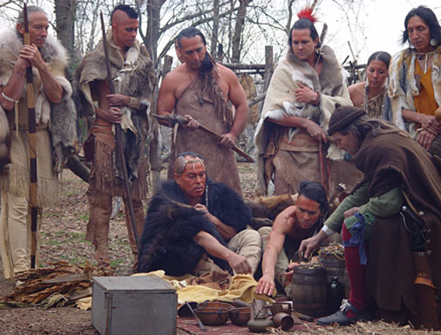

Wampanoag Indians
The Massachusetts Bay colony was settled in the lands of the Wampanoag nation of the Algonquian Indians in southeastern Massachusetts. The chief of the Wampanoag was Massasoit. Several years prior to the Pilgrim's landing the Wampanoag were ravaged by an epidemic. They also feared attack from the Tarrentine Indians from the north, and the Narragansetts from the west.
Massasoit recognized common interests he shared with the colonists: his nation needed protection and the colonists needed supplies and knowledge of how to survive in the wilderness. John Carver, first governor of Plymouth and Massasoit agreed to a peace treaty in 1621 in which they swore no to steal from each other, come to each other's aid, and to protect each other from insurrection.
The tolerance the Pilgrims and Wampanoag showed each other and the peace they worked to maintain were unique in the 17th century. From time to time, each had to yield to the other to preserve peace and address concerns of their citizens, but owing to Bradford's and Massasoit's leadership, peace survived for over 40 years, well after the death of each man.

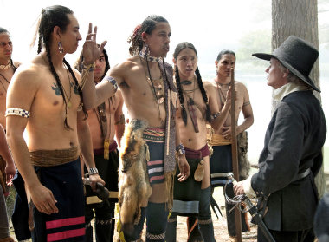

Name:____________________________ Date:_____________

Assistance
Pocahontas
Pocahontas was the favorite daughter of one of Powhatan's several wives. For reasons not fully understood, at the age of 12 or 13 she persuaded her father to save John Smith's life after he was captured in the fall of 1607. In 1609 while traveling to a meeting with the Indians, she informed John Smith of a trap and saved his life a second time.
In April 1613 she was kidnapped and taken to Jamestown and taught English. While in captivity, she became the first Indian to convert to Christianity and was baptized Rebecca. She met John Rolfe, a widower and rich planter and married him in April 1614. In 1616 Rolfe, Lady Rebecca and their infant son Thomas, traveled to England. She was presented at court, aroused great interest, including having her portrait painted wearing jewels and elegant clothes. Just before Rolfe's return to Jamestown in 1617, she died suddenly and left her son Thomas in the care of Rolfe's uncle.
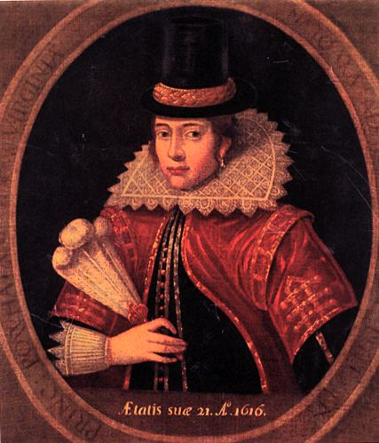

Samoset and Squanto
Samoset was a Wabanakis Indian returning to Maine from a visit to the Nauset Indians on Cape Cod. Years earlier Samoset learned some English from fisherman in Maine. In March 1621 he surprised the Pilgrims when he walked into Plymouth and addressed them in broken English.
Since half of the original Pilgrims died during the previous months, the settlers were in desperate condition. Samoset arranged a meeting between the Pilgrims and Massasoit. As a result Massasoit left one of his tribe, Squanto, to be the Pilgrim's guide and interpreter.
Squanto, born in Patuxet had been kidnapped by Captain Thomas Hunt in 1614 and sold into slavery in Spain. He was rescued by Sir Ferdinando Gorges, taken to England and taught English to become a guide and interpreter for a colony Gorges planned in Newfoundland. The settlement never materialized and Squanto was returned to Patuxet in 1618 only to find his village abandoned whereupon he joined the Wampanoag's.
The Pilgrims were indebted to Squanto because he taught them how to grow native corn, squash, beans, how harvest wild editable forest plants and in general how to survive in the wilderness. Without Squanto's help it is doubtful the Pilgrims would have survived after 1621. Squanto died in 1623 and Massasoit sent another Wampanoag Indian, Hobbamock and his family to live near the Pilgrims to be their guide and interpreter.
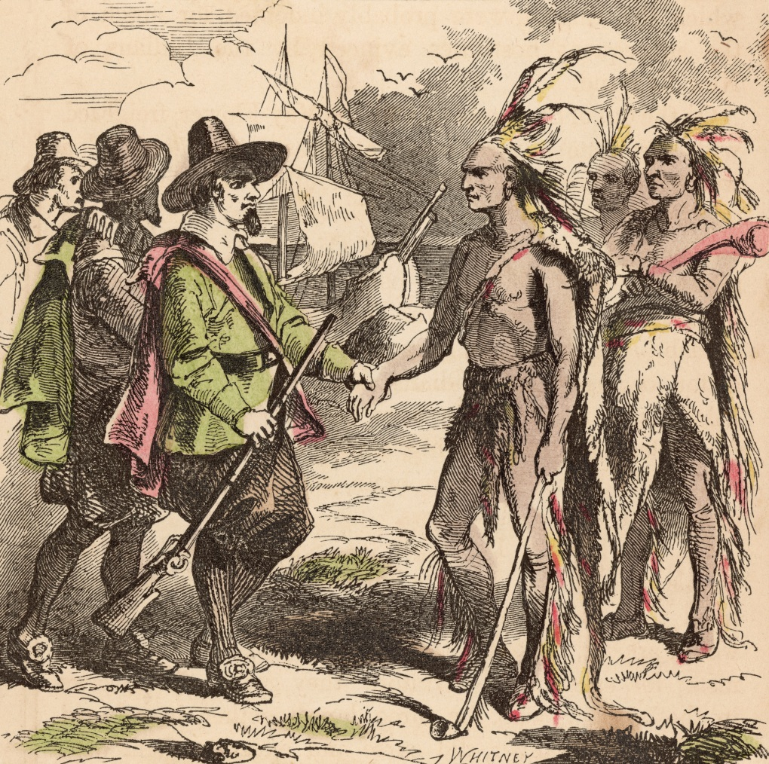

Name:____________________________ Date:_____________

Business Activities
Jamestown
The original goals of the Virginia Company were to discover precious stones and metals, and a water route to the Pacific Ocean. The quest for these goals proved fruitless and the colonists switched to growing and curing tobacco. For centuries tobacco was smoked by the Indians of North and South America for ceremonial purposes and the belief in its medicinal value.
European explorers brought tobacco to Europe in the 1530's. Sir Walter Raleigh introduced tobacco to England to the disgust of King James who banned its use in his presence. Tobacco was prized by Europeans and became the main good produced by colonists to trade for European manufactured goods.
By 1612, John Rolfe learned to grow and cure a West Indian variety of tobacco that was preferred by Englishmen in Virginia. It commanded a high price and it became Jamestown's principal export. The variety of tobacco plants was large, and since it was grown easily, surpluses in European markets often occurred, causing prices to fall quickly.
Tobacco also commanded a large price in the English settlements in New England, the Swedish settlements on the Delaware River and the Dutch in New Amsterdam. After 1619 indentured Englishmen were difficult to procure and Jamestown planters began to use slaves from Africa.
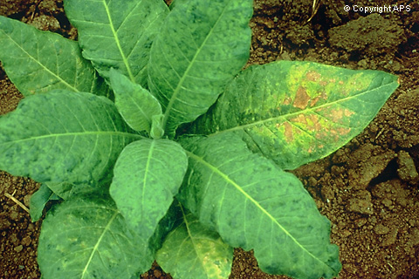

Massachusetts Bay
To finance the voyage to North America the Pilgrims entered into a business agreement with approximately seventy English venture capitalists (manufacturers, craftsmen, merchant-traders). These men called themselves Merchant Adventurers who would pay for the hire of a ship, and supplies for the trip and to sustain the Pilgrims in North America. The settlers agreed to engage in fishing, lumbering or whatever means could generate "cash crops" for transport and sale to England.
While the waters were rich with fish, the Pilgrims never mastered the skills to make necessary profit from fishing. The wilderness provided lumber for export but the financial return was small. Supplies to sustain the colonists were to be sent to the Pilgrims on the return voyage. Robert Cushman was Plymouths agent in London. The agreement was to last for seven years at the end of which, each colonist over the age of 16 was to receive shares of the company as would each Adventurer. All property in the colony was then to be divided amongst all the shareholders.
Initially the colonists participated in communal farming and fishing, where the output went into a common pot. In 1623 the colony assigned land to the heads of families including servants. Under these terms families were granted certain amounts of land to produce a set amount of produce for the colony but they were allowed to keep the remainder to use or sell.
Within a few years the Pilgrims were producing corn crops which were traded for Indian furs that brought a good price in England. In 1627 the Pilgrims built a trading post on the Kennebec River in Maine to trade corn for Indian furs. This began a period of profitable trade. The colony's debts with London were eventually paid and the colony became financially sound. In time the main activity in Massachusetts Bay was to produce agricultural products for the colony.

Name:____________________________ Date:_____________

Women in the Colonies
Jamestown
Jamestown was the first permanent English settlement in the “New World.” In Jamestown, the settlers tried to reconstruct life in England as much as they could. However, life was full of hardships for the settlers which resulted in some drastic changes in the colony, especially when it came to the role of women.
Women in England were thought to be inferior to men. Wives were almost like servants to their husbands. In return however, women were provided with protection from their husbands. Men owned property and enacted contracts, while women had children, raised them and kept the house.
Marriages were not made for love, marriages were made for convince and family advancement. It was common for spouses to tolerate or even hate one another, yet divorces were not granted since marriage was looked upon as a sacrament within the church. However, some changes were made in Jamestown to the traditional English ways.
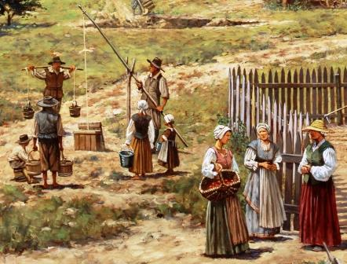
The colony was founded mainly by men due to the harsh and life-threatening conditions in Jamestown. By 1625, the colony was still made up of three-fourths men, which gave the few women who lived in the colony slightly more power. For example, in England, slight beating of your wife was normally ignored, in the colony it was not tolerated at all. Also, some women even refused to recite that they would obey their husbands during the wedding ceremony. Although the changes were minor, they reflected that changes would come eventually. In most other aspects, women’s roles in Jamestown mirrored those in England.

Massachusetts Bay
Massachusetts Bay was settled by Puritans, whose beliefs differed from “traditional Englishmen” in a number of ways, one in particular being the role of women within the society. The reasoning behind the different treatment of women in the Massachusetts Bay colony, springs from the Puritan belief that family stability and harmony is highly valuable since the family is the model of the church and state and therefore, essential to social order. Men and women were both held accountable for family stability, and any challenge to the harmony was strictly punished.
Since the Puritans did not view marriage as a sacrament within the church, it was viewed as a contract between the man and woman. However, this contract was not entered into lightly. Puritans wanted a marriage based on love and wanted the couple to be well-suited for one another. Puritans even granted divorces when the marriage contract was broken. The contract could be broken by failure to provide for the family, bigamy or adultery, or desertion.
However, men and women were not viewed as equals. Women were still thought to be inferior to men, but their souls were thought to be equal. However, women were treated fairly in a courtroom and could enact treaties and own property in Massachusetts Bay, which was a big step for women’s rights and practices not normally followed in England at this time.
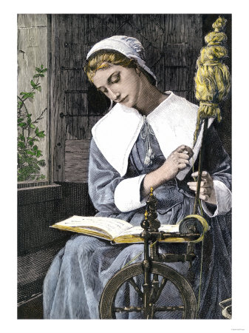

Name:____________________________ Date:_____________

Slavery in the Colonies
Jamestown
In 1619 a Dutch slave ship brought 20 Africans to Jamestown. The captain of the ship traded his slaves for food and the Africans became indentured servants. White farmers traded their tobacco for Africans and made them work on their tobacco plantations.
African indentured servants were usually very cheap but the African indentured servants were given the same treatment as white indentured servants. African indentured servants were freed after a 4-7 years, just like white servants. Any servants, who had been freed, no matter what race, were able to vote, own land, marry, participate in government and fight for the army.
However, plantation owners soon realized that they were losing money by buying new indentured servants every few years. Plantation owners thought about enslaving Native Americans. However, Native Americans could easily run away because they knew the land. Therefore, plantation owners started keeping their African indentured servants longer.
By the late 1600s a series of laws were passed that stopped African indentured servants from being freed, making them slaves and limiting their rights. These laws also stopped them from marrying white people and also made it so that any children born to slaves became slaves too.
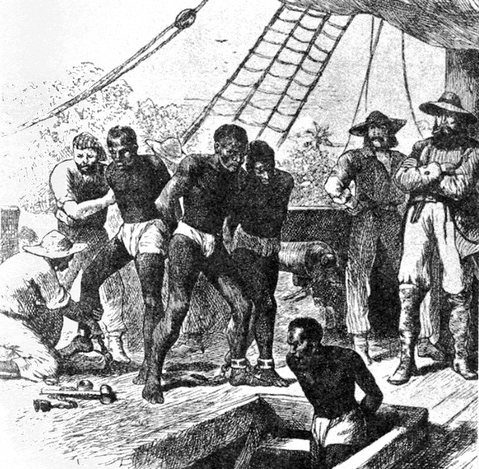

Massachusetts Bay
Slavery was legalized in Massachusetts by 1641. Massachusetts was actually the first slave-holding colony in New England. In fact, most, if not all, of the 1600’s New England slave trade was in the hands of Massachusetts merchants. Boston merchants made New England's first attempt at direct import of slaves from West Africa to the West Indies in 1644, and were partially successful.
However, by 1676, Boston ships had pioneered a slave trade to Madagascar, and they were selling slaves to Virginians by 1678. For the home market, the Puritans generally took the Africans to the West Indies and sold them in exchange for a few experienced slaves, which they brought back to New England. In other cases, they brought back the weaklings that could not be sold on the harsh West Indies plantations and tried to get the best bargain they could for them in New England. Massachusetts merchants and ships were supplying slaves to Connecticut by 1680 and Rhode Island by 1696.
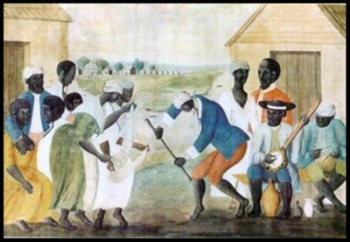
In the early 1700’s, New England began an aggressive pursuit of the slave trade. At the same time, the expansion of New England industries created a shortage of labor, which the slaves filled. From fewer than 200 slaves in 1676, and 550 in 1708, the Massachusetts slave population jumped to about 2,000 in 1715. It reached its largest percentage of the total population between 1755 and 1764, when it stood at around 2.2 percent.

