Chapter 3: Europeans Compete for Colonial Empires (1492-1610) Review
Vocabulary: Match the words with their definition.

________Viceroy
________ Hacienda
________ Ecomienda
________ Mission
________ Ranchos
________Raw Materials
________Piracy
________Protestants
________King Philip II
________The Spanish Armada
________The English Channel
________Sir Walter Raleigh
________Roanoke Island
________Parliament
________Joint-Stock Companies
________Investor
________Shares of Stock
________Charters
________Proprietors
_______Indentured Servants

- Workers who sold their labor in exchange for passage to the American colonies.
- Colonial Governor
- Robbery at sea.
- 130 war ships gathered by King Philip II to attack England but were defeated. The battle marked the decline of Spain being the strongest country in Europe.
- People who put money into a project in order to earn profits.
- Religious settlements founded by priests for the purpose of spreading the Catholic faith.
- Nobles who used their own money to start colonies.
- Cattle Ranchers
- The right of a property owner to demand labor from the Indians on the land.
- A narrow strait between England and France.
- A paper giving certain rights to a person or rights.
- Large estates
- Natural resources used to make other goods.
- Members of Christian churches founded in protest against Catholic teaching.
- Equal parts in owning a company.
- England’s law making body.
- The first English settlement in the Americas, that vanished.
- The leader of Spain who was angry about the attacks by pirates and at England for becoming Protestants.
- Founded the first English settlement in the Americas.
- Trading companies backed by investors.

Social Classification: Use the Word Bank to identify the different levels of Spanish society.

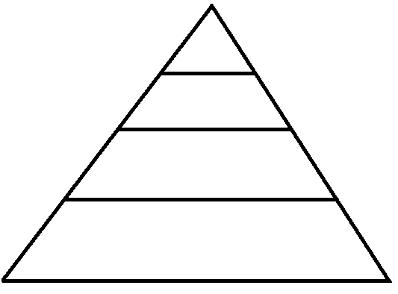
Word Bank:
Peninsulares – Spanish born in Spain. The occupied the most important positions in the government and church. They held all the political power and controlled the colonies.
Creoles – People of Spanish descent that were born in the colonies. Occupied positions as landowners and merchants, and were wealthy.
Mestizos – People of mixed Spanish descent and Indian Ancestry. They mostly worked as artisans in cities or labors on farms.
Native Americans and Black Slaves from Africa – They did the hardest work in the fields and in mines. They often lived in poverty and near starvation.
Word Bank:

Label the Spanish Colonies in South America and their capitals:
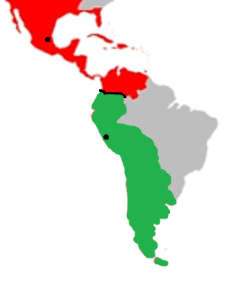
Word Bank:
New Spain – Included Venezuela and lands North of Panama. Capital City is Mexico City.
Peru – Included all Spanish land in South America except Venezuela. Capital city is Lima.

